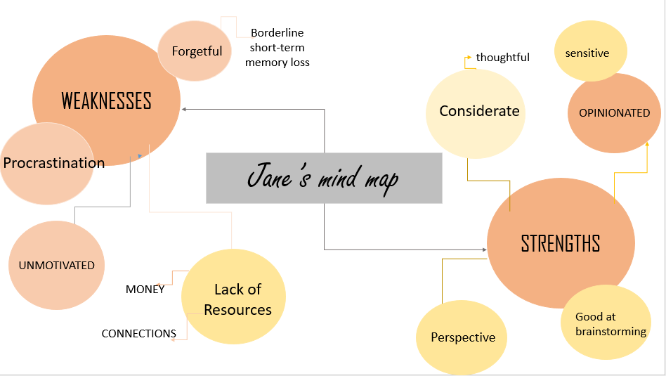

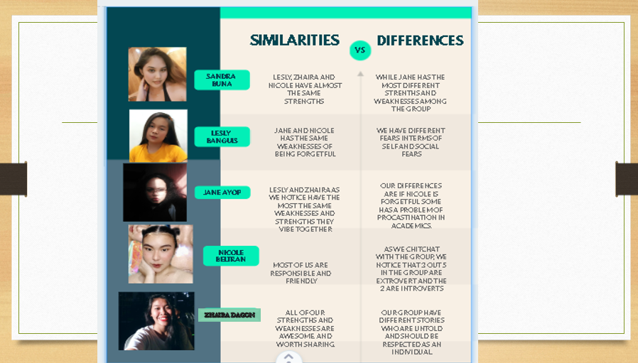

Making this activity had me reorganize my current strengths and weaknesses. This had also made me understand myself a little more. As a not-so-positive person, the weaknesses section was the easiest thing to do. The pandemic and practicing isolation in a year and a half really brought out the worst in me. In less than a year, I watched myself decline. With my current state of mind, I have to ask my sister about my strengths. As she list some of it down for me, I realized I still have some best points I could be proud of. I have included being sensitive in my strengths even though it has a negative connotation, but being sensitive made some people I know thankful for me. I had helped them in some way by being sensitive (i.e. questioning abuse being normalized, below-the-belt-jokes, etc.). Knowing that I have helped someone, despite my failing mental health, made my inner self satisfied. Discussing our own weaknesses and strengths in our group, had also helped me understand them more. We share some of our weak points (i.e. procrastinating, laziness.), and it’s good to know that they don’t let their weaknesses control them as seen in their strengths. To note, the activity is helpful for people with disorganized thoughts.